Impact of Process Variables and Loading Conditions on the Fatigue Life of EB-PBF-Manufactured Ti6Al4V Alloys

Costanzo Bellini, Vittorio Di Cocco
DICeM, University of Cassino and Southern Lazio, Via G. di Biasio 43,03043 Cassino, Italy
costanzo.bellini@unicas.it, vittorio.dicocco@unicas.it

Filippo Berto, Stefano Natali, Daniela Pilone, Carolina Schillaci
DICMA, Sapienza University of Rome, Via Eudossiana 18, 00184 Rome, Italy
filippo.berto@uniroma1.it, stafano.natali@uniroma1.it, daniela.pilone@uniroma1.it, carolina.schillaci@uniroma1.it

Rosario Borrelli, Stefania Franchitti
Additive Manufacturing LAB, CIRA, Via Maiorise 1, 81043 Capua, Italy
r.borrelli@cira.it, s.franchitti@cira.it

Paolo Di Giamberardino, Daniela Iacoviello
DIAG, Sapienza University of Rome, Via Ariosto 25, 00184 Rome, Italy
paolo.digiamberardino@uniroma1.it, daniela.iacoviello@uniroma1.it

Abstract. Additive Manufacturing allows the fabrication of complex shape parts, but the manufacturing processes may introduce defects that undermine the mechanical performance. In the presented study, the influence of selected process parameters and testing conditions on the fatigue life of Ti6Al4V alloys produced by Electron Beam-Powder Bed Fusion (EB-PBF) has been studied.
To study the effects of process parameters, the EB-PBF machine was operated in manual mode, bypassing proprietary manufacturing algorithms. Moreover, various load ratios were considered for fatigue tests conducted under constant-amplitude loads.
The results established a direct relationship between energy density, microstructure, and fatigue resistance. It was found that the beam current and the scan speed significantly determined the energy density of the process and, consequently, the material porosity and density, so affecting the mechanical performance. These findings indicate that careful selection and control of manufacturing parameters can enhance fatigue properties in EB-PBF components. This information can be used to support the development of AI-based optimisation strategies to predict stress-related behaviour and minimise defects, such as cracking and residual stress.

Keywords. Ti6Al4V, Fatigue Behaviour, Load Ratio, Energy Density.

Introduction

According to several authors, additive manufacturing (AM) is among the most significant emerging techniques in advanced manufacturing, allowing components with complex geometry to be fabricated directly from digital models [1,2]. Powder Bed Fusion (PBF) methods, which use a high-energy source to selectively melt and fuse layers of metallic powder, have garnered a lot of attention among the different AM procedures for creating high-performance, end-use parts. In contrast to laser-based counterparts, Electron Beam-Powder Bed Fusion (EB-PBF) has become popular due to its capacity to create parts made of high-temperature reactive alloys in a high-vacuum environment, resulting in components with low contamination and reduced residual stresses [3,4].
One of the best options for the EB-PBF technology is the titanium alloy Ti6Al4V. It has become an essential component in the demanding fields of aerospace, defence, and biomedical implants thanks to its outstanding combination of high specific strength, outstanding corrosion resistance, and very high biocompatibility [5,6]. Next-generation structural components, patient-specific orthopaedic implants, and complex aeronautical gear can all be produced by combining the design freedom provided by EB-PBF with the exceptional qualities of Ti6Al4V [7,8]. However, the promise of Ti6Al4V generated by EB-PBF can only be completely realised if its mechanical properties are properly understood and assured, particularly under cyclic loading circumstances. In many applications, the component fatigue life is frequently the most important design factor because catastrophic failure might have disastrous outcomes.
The specific temperature history that the material undergoes during the layer-by-layer manufacturing process is inextricably tied to the mechanical behaviour of EB-PBF-manufactured products. Complex temperature gradients and solidification dynamics are produced by the electron beam quick heating and conductive cooling of previously formed material [9]. This, in turn, controls how the microstructure of the material changes and how process-induced flaws develop. The EB-PBF process in Ti6Al4V usually results in a distinctive microstructure that is dominated by coarse, columnar prior-β grains that develop epitaxially across many layers, aligned with the build direction, which is the principal route of heat dissipation [10,11]. When these prior-β grains cool, a finer Widmanstatten or basket-weave α+β lamellar structure develops [12,13]. The equiaxed microstructures present in Ti6Al4V differ from this highly rough microstructure [14].
The intrinsic unpredictability and anisotropy of the generated mechanical characteristics provide a significant obstacle to the broad use of EB-PBF for fatigue-critical applications. One of the most important parameters controlling this anisotropy is the part orientation regarding the build platform or build orientation. Material reaction is significantly influenced by the direction of grain development with respect to the applied stress axis. The anisotropic tensile properties of EB-PBF Ti6Al4V have been reported in several studies. Gong et al. found that tensile specimens built vertically, with the tensile axis parallel to the build direction, exhibit lower ductility than those built horizontally, with the tensile axis perpendicular to the build direction [15]. The direction of the long columnar prior-β grain boundaries, which can serve as preferred routes for damage buildup when loaded transversely, is responsible for this discrepancy. Seifi et al. investigated the impact of post-process Hot Isostatic Pressing (HIP) as well as location-specific flaws and microstructure [16]. The authors connected mechanical performance with microstructural characteristics using fractography, µCT scans, and EBSD. As-deposited samples exhibited flaws such as porosity and lack of fusion, but their fracture characteristics were similar to those of wrought Ti-6Al-4V. These flaws were removed by the HIP treatment, but it also resulted in microstructural coarsening, which significantly changed the material toughness and resistance to fatigue fracture formation. Under fatigue loading circumstances, this anisotropy is considerably more noticeable and crucial. A material microstructure and the existence of flaws, which serve as stress concentrators and crack initiation sites, have a significant impact on its fatigue life. Both factors are influenced by the building orientation. First, according to Edwards and Ramulu, the orientation of the lamellar α+β colonies within the columnar grains with respect to the loading direction influences the tortuosity of the crack channel, which in turn influences the fatigue crack growth rate [17]. Compared to a crack travelling parallel to the grain and colony boundaries, a crack propagating perpendicular to the long axis of the columnar grains may run against more microstructural barriers. Second, the build orientation may affect the type and orientation of process-induced defects, including lack-of-fusion (LoF) pores. These flaws, which are frequently planar and elongated, behave like acute pre-cracks and are most harmful when they are oriented perpendicular to the major stress axis [18].
The aim of the present work consists in evaluating the effect of the manufacturing process and the testing conditions on the fatigue properties of additively manufactured specimens. In particular, the EB-PBF process was considered. Here is the outline of this article: first of all, in the materials and methods paragraph, there is the definition of the case study. In particular, the specimen is defined in terms of type and dimensions, together with the process parameters to be considered and the materials to be used for this work. Also, the test conditions, that is the load ratio values to be used during the experimental campaign, are set, because it influences the number of specimens to be tested. After, there is the presentation of the specimens manufacturing, which is formed by two steps: in the first, metal plates were made through EB-PBF, in the second, the holes and the notch were machined. After, there is the presentation of the testing procedure and equipment. Finally, in the relevant paragraph, the results obtained from the experimental test are presented.
Materials and methods

The specimen considered for this activity was the Compact Tension (CT) one, as described in the ASTM E647 standard. As notable in Figure 1, the specimen had a nearly square form, measuring 50 mm in length and 48 mm in width, with a thickness of 8 mm. The notch width was 2.5 mm, and its tip was situated 8 mm from the line connecting the loading pin holes centres. The Ti6Al4V alloy, which is frequently utilised in the aviation sector, was the source of the titanium powder used in this study. High-quality powder was supplied by the printing machine manufacturer. Because the particles roll and pack together to create a denser powder bed, the high sphericity of the particles is crucial for this type of procedure because it improves flowability, in order to allow good powder melting and reduce the defect formation.

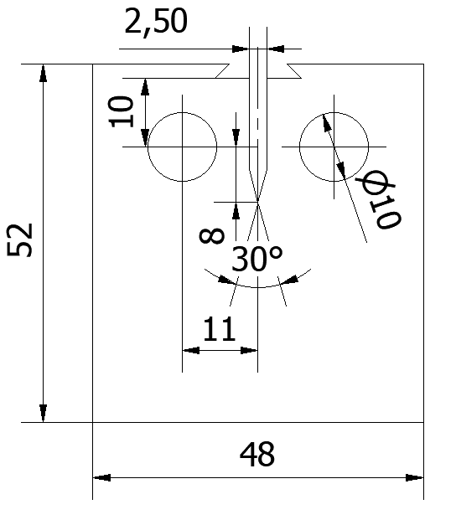

Figure 1: Specimen dimension.

By varying the beam current and speed, four distinct sets of process parameters were produced. The hatch distance, the layer thickness, the focus offset, and the beam voltage were all maintained at constant values. Different energy density values were produced in this way, as visible in Table 1. Specifically, the first set, indicated as A, had the maximum energy, which was required to produce entirely dense, defect-free pieces; the subsequent sets, called B and C, had lower energy, which introduced varying amounts of flaws. In fact, the energy densities were quite similar even though the B and C sets had very different parameters—for example, the C beam current was double that of the B set—because the beam speed balanced the current variation. Finally, specimen type D presented the lowest level of energy density.

Set | s (mm/s) | I (mA) | h (mm) | FO (mA) | t (mm) | v (kV) | VED (J/mm3)
A | 4530 | 15 | 0.1 | 3 | 0.05 | 60 | 39.74
B | 6000 | 8 |  |  |  |  | 16.00
C | 10000 | 15 |  |  |  |  | 18.00
D | 9600 | 8 |  |  |  |  | 10.00

Table 1: Process parameters used for specimen manufacture.

As concerns the manufacturing process of the specimens, an EB-PBF 3D printer was used, that was the ARCAM A2X controlled by the software EBM Control 3. Following the creation of the specimen geometry, they were organised in the workspace and sliced using the software Magics Materialise. The powder hoppers were filled, and the process settings were established when the machine was ready for the manufacturing run. The vacuum was created, the electron beam was calibrated, and the start plate was then preheated. The specimens were constructed in accordance with the standard procedure of a powder bed additive manufacturing technique once the required temperature was obtained. The specimens were removed from the unmelted powder and cleaned once the chamber had cooled. Lastly, the notch and loading pin holes were machined in the specimens. Concerning the specimen position and orientation inside the working space of the machine, the plane of the specimen was perpendicular to the growth direction. In this manner, the columnar grains, due to the solidification process, are in this case perpendicular to the main plane of the specimen, so a good degree of isotropy was expected in the plane. Therefore, a single crack orientation was considered in this work. Fatigue crack growth tests were performed on CT specimens using a computer-controlled servohydraulic testing machine. This equipment allowed for the precise and automated execution of the test protocols. For the experimental tests, three different levels of load ratio R were considered: 0.1, 0.5 and 0.75. The other experimental conditions were a loading frequency of 30 Hz, a sinusoidal waveform and the test was carried out at room temperature.

Results

In this paragraph, the Paris curves for the tested specimens are reported. The graph plots the fatigue crack growth rate (da/dN) as a function of the stress intensity factor range (ΔK) on a log-log scale. The plots in Figure 2 show the results for the A specimens and the B specimens. It can be noted that at a low load ratio, that is 0.1, the B specimen performs better, since values of ΔK between 8 MPa√m and 30 MPa√m were found, while for the A specimen, they were between 7 MPa√m and 30 MPa√m. As concerns higher load ratio values, that is 0.5 and 0.75, the A curves are slightly more on the right compared to the B ones, especially the 0.75 one. However, also in this case, the difference is almost negligible. What is important, instead, and can be easily noted, is the crack closure effect. In fact, for higher load ratios, the curves tended to move towards the left, with an apparent decrease of fatigue strength. This is because the crack closes before the complete release of the load, because of several phenomena, like the presence of particles, or the plastic deformation of the surfaces themselves. This reduces the effective stress intensity range. Moreover, a saturation of this effect can be noted at higher values of R. In fact, passing from 0.5 to 0.75 as the R value does not affect the curves.

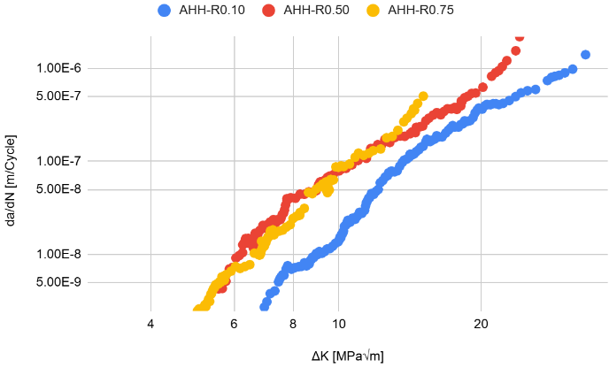 a 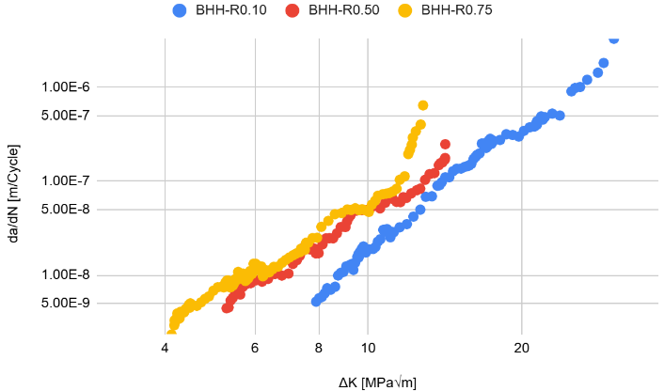 b

Figure 2: Fatigue crack growth: a) specimens A; b) specimens B.

As concerns the other two specimens, C and D, the crack closure effect can be noted in this case too, even if for the D specimens this phenomenon is less evident. In fact, as visible in Figure 3, the curves are almost overlapping. The curves for the specimens C show a good similarity to those of specimens B, while the curves of specimens D are completely moved to the left and the top, that is the crack grows for lower ΔK and at a higher rate. This denotes a lower fatigue strength.

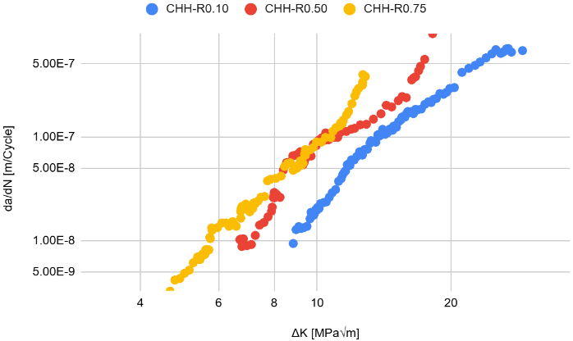 a 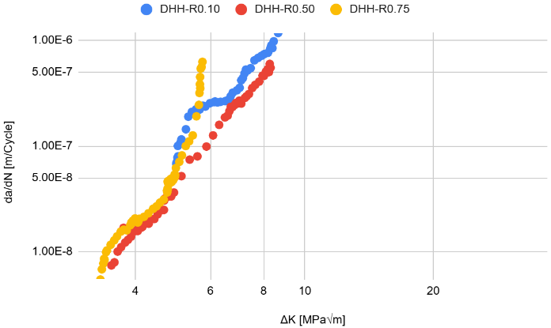 b

Figure 3: Fatigue crack growth : a) specimens C; b) specimens D.

To better explain the fatigue crack growth behaviour, some SEM micrographs were taken on the fracture surface of the broken specimens. Starting with the first set of fractographs, the fracture surfaces of specimens A and D, at the low load ratio of 0.1, are presented in Figure 4. At this 500x magnification, the morphological evidence is in perfect agreement with the mechanical data previously discussed regarding the crack closure effect. The most striking feature across all samples is the presence of significant rubbing marks and flattened areas, which are classic indicators of plasticity-induced crack closure.

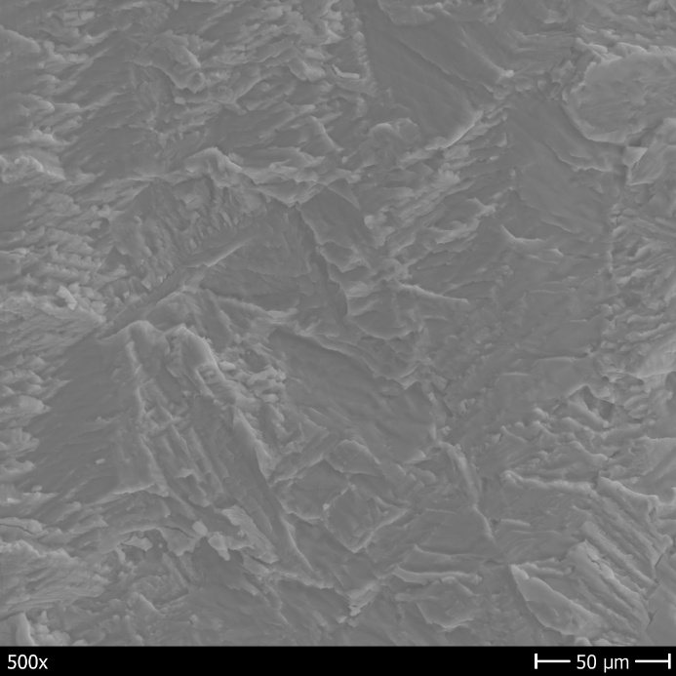 a 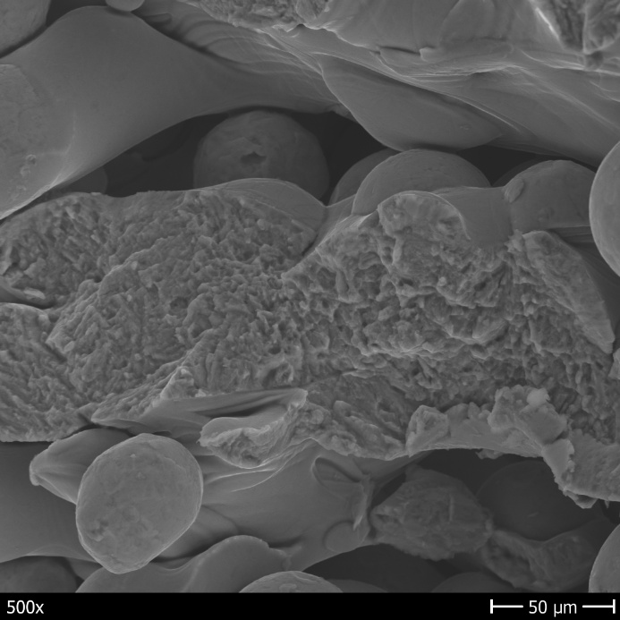 b

Figure 4: Fracture surface for R=0.1: a) specimen A; b) specimen D.

Figure 5 displays the fracture surfaces of the specimens subjected to a high load ratio of 0.75, where the closure effects are effectively eliminated. In Figure 5a, relevant to specimen A, the features are remarkably crisp and well-preserved, confirming that the crack tip remains fully open throughout the entire loading spectrum. This allows observing the intrinsic fatigue mechanisms without any external interference from surface rubbing. In Figure 5b, specimen D exhibits a distinctly more irregular topography. The presence of micro-discontinuities and a more aggressive damage pattern in this specimen provides the physical justification for its poor mechanical performance. This confirms that the weakness of the D-type material is not merely a statistical variation but is deeply rooted in its fracture kinematics, making it the most vulnerable variant among the batches analysed in this study.

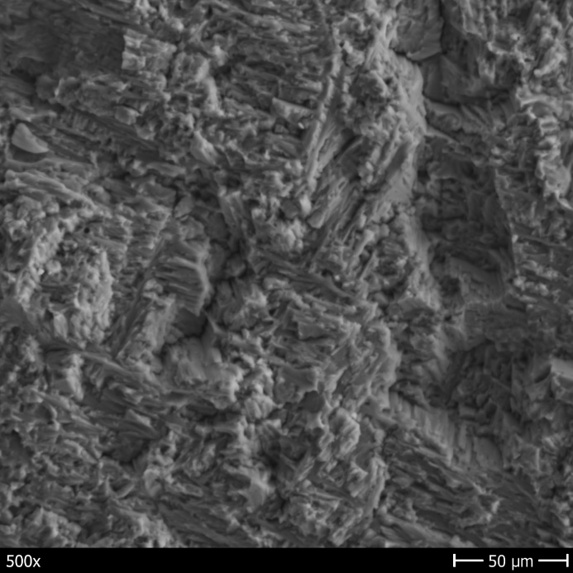 a 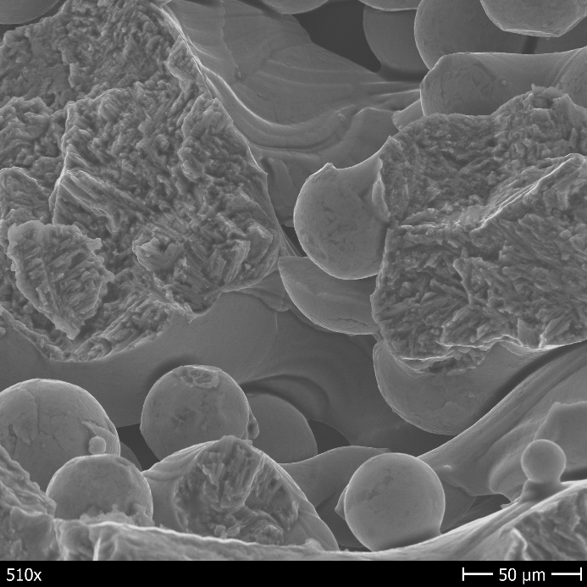 b

Figure 5: Fracture surface for R=0.75: a) specimen A; b) specimen D.
Conclusion

This research has provided a comprehensive characterisation of the fatigue crack growth behaviour across different material variants, integrating macroscopic propagation data with rigorous statistical modelling and microscopic observations. The first major outcome of this study concerns the influence of the load ratio. The crack closure effect is the dominant mechanism at low R ratios, acting as a crucial extrinsic shielding factor that significantly reduces growth rates. However, the observed saturation of this effect at load ratios above 0.50 indicates that under high mean-stress operating conditions, the structural integrity of the components relies solely on the intrinsic microstructural resistance of the material. The comparative analysis of the different batches identified specimen D as the critical outlier of the series. While types A, B, and C exhibited consistent and comparable fatigue performance, specimen D systematically showed higher crack growth rates across all tested conditions. This divergence was not only confirmed by the Paris law parameters but also validated through SEM fractography, which revealed a more irregular fracture morphology for the D-type batch, suggesting an inherent microstructural vulnerability that warrants further process optimisation.

Acknowledgments

This research was made possible with funding from the European Union – Next Generation EU, Mission 4 Component 1, which was administered through the Italian Ministry of University and Research as part of the PRIN 2022 program. The unique project code (CUP) for this work is H53D23001200006.

References

[1] Frazier, W.E. (2014). Metal additive manufacturing: A review, J. Mater. Eng. Perform., 23(6), pp. 1917–28, Doi: 10.1007/s11665-014-0958-z.
[2] Borrelli, R., Bellini, C., Berto, F., Di Cocco, V., Foti, P., Iacoviello, F., Mocanu, L.P., Pirozzi, C., Razavi, N. (2024). The impact of Ti6Al4V powder reuse on the quality of electron beam powder bed fusion parts, Prog. Addit. Manuf., 9, pp. 1475–1490, Doi: 10.1007/s40964-023-00560-2.
[3] Körner, C. (2016). Additive manufacturing of metallic components by selective electron beam melting - A review, Int. Mater. Rev., 61(5), pp. 361–77, Doi: 10.1080/09506608.2016.1176289.
[4] Murr, L.E., Gaytan, S.M., Ramirez, D.A., Martinez, E., Hernandez, J., Amato, K.N., Shindo, P.W., Medina, F.R., Wicker, R.B. (2012). Metal Fabrication by Additive Manufacturing Using Laser and Electron Beam Melting Technologies, J. Mater. Sci. Technol., 28(1), pp. 1–14, Doi: 10.1016/S1005-0302(12)60016-4.
[5] Bellini, C., Borrelli, R., Di Cocco, V., Franchitti, S., Iacoviello, F., Mocanu, L.P., Sorrentino, L. (2024). Titanium/FRP hybrid sandwich: in-plane flexural behaviour of short beam specimens, Fract. Struct. Integr., 18(69), pp. 18–28, Doi: 10.3221/igf-esis.69.02.
[6] Cantaboni, F., Battini, D., Hauber, K.Z., Ginestra, P.S., Tocci, M., Avanzini, A., Ceretti, E., Pola, A. (2024). Mechanical and microstructural characterization of Ti6Al4V lattice structures with and without solid shell manufactured via electron beam powder bed fusion, Int. J. Adv. Manuf. Technol., 131, pp. 1289–301, Doi: 10.1007/s00170-024-13137-2.
[7] Bellini, C., Borrelli, R., Di Caprio, F., Di Cocco, V., Franchitti, S., Iacoviello, F., Pirozzi, C., Sorrentino, L. (2023). Geometrical Accuracy Analysis of Ti-6Al-4V Trusses Manufactured by Electron Beam Melting Process, Metals (Basel)., 13(8), Doi: 10.3390/met13081454.
[8] Epasto, G., Palomba, G., D’Andrea, D., Guglielmino, E., Di Bella, S., Traina, F. (2019). Ti-6Al-4V ELI microlattice structures manufactured by electron beam melting: Effect of unit cell dimensions and morphology on mechanical behaviour, Mater. Sci. Eng. A, 753(November 2018), pp. 31–41, Doi: 10.1016/j.msea.2019.03.014.
[9] Kobryn, P.A., Semiatin, S.L. (2001). The laser additive manufacture of Ti-6Al-4V, JOM, 53(9), pp. 40–2, Doi: 10.1007/s11837-001-0068-x.
[10] Al-Bermani, S.S., Blackmore, M.L., Zhang, W., Todd, I. (2010). The Origin of Microstructural Diversity, Texture, and Mechanical Properties in Electron Beam Melted Ti-6Al-4V, Metall. Mater. Trans. A, 41(13), pp. 3422–34, Doi: 10.1007/s11661-010-0397-x.
[11] Tan, X., Kok, Y., Tan, Y.J., Descoins, M., Mangelinck, D., Tor, S.B., Leong, K.F., Chua, C.K. (2015). Graded microstructure and mechanical properties of additive manufactured Ti-6Al-4V via electron beam melting, Acta Mater., 97, pp. 1–16, Doi: 10.1016/j.actamat.2015.06.036.
[12] Bellini, C., Borrelli, R., Di Cocco, V., Franchitti, S., Iacoviello, F., Mocanu, L.P., Sorrentino, L. (2024). Effects of the manufacturing process on the flexural properties of EBMed lattice structures, Fatigue Fract. Eng. Mater. Struct., 47(12), pp. 4729–40, Doi: 10.1111/ffe.14449.
[13] Schillaci, C., Pilone, D., Berto, F., Bellini, C., Cocco, V. Di., Giamberardino, P. Di., Iacoviello, D. (2025). Correlation between process parameters and mechanical properties of Ti6Al4V alloys processed by electron beam melting, Fract. Struct. Integr., 74, pp. 310–20, Doi: 10.3221/IGF-ESIS74.19.
[14] Rafi, H.K., Karthik, N. V., Gong, H., Starr, T.L., Stucker, B.E. (2013). Microstructures and Mechanical Properties of Ti6Al4V Parts Fabricated by Selective Laser Melting and Electron Beam Melting, J. Mater. Eng. Perform., 22(12), pp. 3872–83, Doi: 10.1007/s11665-013-0658-0.
[15] Gong, H., Rafi, K., Gu, H., Janaki Ram, G.D., Starr, T., Stucker, B. (2015). Influence of defects on mechanical properties of Ti-6Al-4V components produced by selective laser melting and electron beam melting, Mater. Des., 86, pp. 545–54, Doi: 10.1016/j.matdes.2015.07.147.
[16] Seifi, M., Salem, A., Satko, D., Shaffer, J., Lewandowski, J.J. (2017). Defect distribution and microstructure heterogeneity effects on fracture resistance and fatigue behavior of EBM Ti–6Al–4V, Int. J. Fatigue, 94, pp. 263–87, Doi: 10.1016/j.ijfatigue.2016.06.001.
[17] Edwards, P., Ramulu, M. (2014). Fatigue performance evaluation of selective laser melted Ti-6Al-4V, Mater. Sci. Eng. A, 598, pp. 327–37, Doi: 10.1016/j.msea.2014.01.041.
[18] Fleishel, R., Ferrell, W., TerMaath, S. (2023). Fatigue-Damage Initiation at Process Introduced Internal Defects in Electron-Beam-Melted Ti-6Al-4V, Metals (Basel)., 13(2), Doi: 10.3390/met13020350.

